***Set for Team 161***

Among the many curious movements of all pieces in a chess game, the Queen’s movement is interesting. The Queen can move through any number of squares in any direction: in the same line, in the same column or in any of the diagonals. The following figure illustrates the possible movements the Queen can make from a given position.

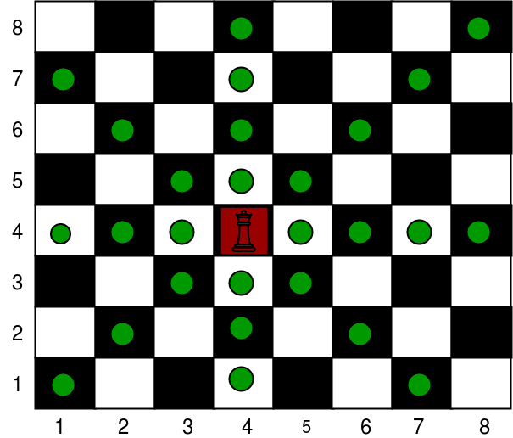

Suppose, in an 8 by 8 board, the Queen needs specific number of movements to go from one square to another. If the squares can be considered as Cartesian Co-ordinate plane, starting from (1,1) from the lower leftmost corner of the board, and if you are asked to create a computer program in C that can tell the user, upon given two co-ordinate points about the board referring where the Queen currently is and whether the Queen will go on next move. Write a C program that can indicate the smallest number of moves needed for the queen to reach to the new co-ordinate position.

**Input**  
The input contains several test cases. The only line of each test case contains four integers **X1, Y1, X2 and Y2 (1 ≤ X1, Y1, X2, Y2 ≤ 8)**. **The queen starts in the square with coordinates (X1, Y1), and must finish at the square with coordinates (X2, Y2).** In the chessboard, columns are numbered from 1 to 8, from left to right; lines are also numbered from 1 to 8, from top to bottom. The coordinates of a square in line X and column Y are (X, Y).

**The end of input is indicated by a line containing four zeros, separated by spaces.**

**Sample Input and Output**

4 4 6 2 --------> 1

3 5 3 5 --------> 0

5 5 4 3 --------> 2

0 0 0 0 --------> //Program terminates